Promotional materials for Hennepin County’s Plastic-Free Challenge

About the challenge
Although plastic is a versatile material with many uses, it is also concerning because it presents health risks, contributes to litter and pollution, and is challenging to dispose of. Some of the most common and problematic plastic items we deal with every day come in the form of packaging and single-use plastics.
Hennepin County’s Plastic-Free Challenge engages residents in learning about plastics and plastic waste and committing to actions that help create a plastic-free world. The challenge has 70 actions to choose from in seven categories. Participants check off the actions they already take, then select up to five one-time actions and five daily actions to track progress on during the four-week challenge.
Organizations and businesses, including community groups, neighborhoods, schools, retailers, and more, can become a Plastic-Free Challenge Partner by helping to increase promotion, recruitment, and engagement for the challenge. The online Plastic-Free Challenge is powered by EcoChallenge.

Help spread the word and encourage others to join
Some ways you can help spread the word about the Plastic-Free Challenge and encourage others to join:
- Download and share the social media graphics. Sample social media posts to go with the graphics are included in this document.
- Download and share the “I Joined” graphics. Encourage your friends and family to join too!
- Create a team or join an existing team and invite people you know – your friends, family, neighbors, colleagues, etc. – to join you. Your teammates will keep each other motivated and accountable. Invitations can be sent through the EcoChallenge website or using the email message included in this document.
- Become a Plastic-Free Challenge Partner – details about partnership are on page 2.
- Follow and reshare messages posted on the Hennepin County Environment and Energy social media channels: Hennepin Environment on Facebook and @hennepinenviro on Twitter
- Use the sample newsletter article to share through your organizations.

Become a 2022 Plastic-Free Challenge partner
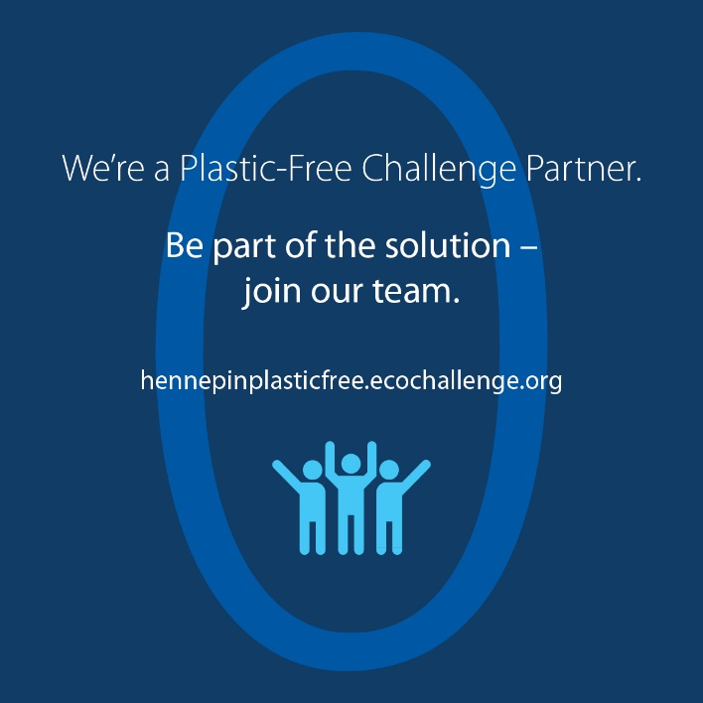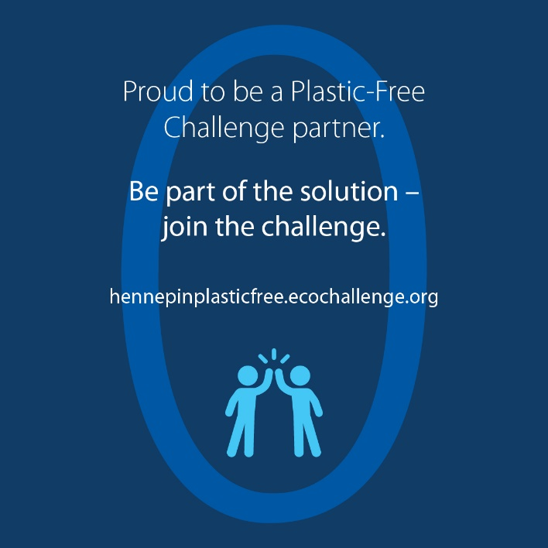
Hennepin County is working to reduce plastic waste as part of achieving our zero waste and climate action goals. As part of this effort, Hennepin County offers the Plastic-Free Challenge to engage residents in learning about plastics and committing to actions that help create a plastic-free world.
But we can’t do it alone!
For the upcoming Plastic-Free Challenge, which will run in February 2022, Hennepin County is seeking partners to help increase promotion, recruitment, and engagement for the challenge.
All partners will have their logo displayed on the challenge website, gain access to promotional materials, and get various recognition and cross-promotion during the challenge. There is no cost to becoming a partner.

Partnership opportunities include:
- Expanding our reach by promoting the challenge to your audiences.
- Strengthening engagement in the challenge by creating teams of colleagues, friends, and neighbors who motivate and hold each other accountable.
- Increasing our impact by offering educational events on plastic-free topics or discounts on plastic-free goods and services.
See the Plastic-Free Challenge partnership guide (PDF) for details on partnership opportunities, and fill out the partnership form to become a 2022 Plastic-Free Challenge partner.

Download partner posters:
- Join our Plastic-Free Challenge team 11x17 (PDF)
- Join our Plastic-Free Challenge team 8.5x11 (PDF)
- Proud to be a Plastic-Free Challenge partner 11x17 (PDF)
- Proud to be a Plastic-Free Challenge partner 8.5x11 (PDF)
- Be part of the solution - join the Plastic-Free Challenge 11x17 (PDF)
- Be part of the solution - join the Plastic Free Challenge 8.5x11 (PDF)

Sample newsletter article (long)

Our actions help create a plastic-free world: Join Hennepin County’s Plastic-Free Challenge
Plastics are problematic for many reasons. They create waste and litter, contribute to climate change, pollute our water, harm wildlife, and have largely unknown health impacts for us.
Be part of the solution to reduce waste, protect water and wildlife, address climate change, and look after the health of ourselves and future generations by joining the Hennepin County Plastic-Free Challenge and committing to actions that help create a plastic-free world.

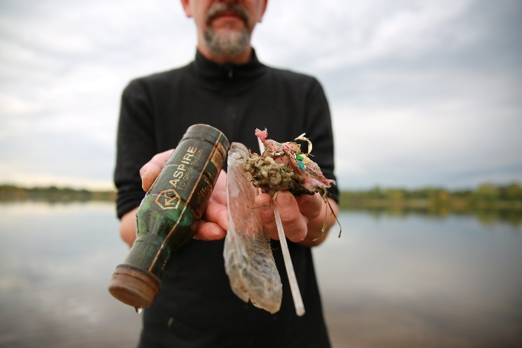
The problem with plastics
Plastics are problematic for many reasons. Worldwide, plastic production has skyrocketed since the 1970s, and a lot of the growth has come in the form of packaging and single-use plastics. Most plastics are made from oil and gas – fossil fuels that contribute to climate change. About 4% to 8% of the world's oil production is for plastics, and most plastics are thrown away after a single use.
Since packaging and single-use plastics are used for a short period of time and then discarded, they contribute significantly to the increasing amounts of plastic waste and litter. Although recycling can be a good option for managing certain plastic items, only a small percentage of plastic products are recycled, and many types of plastic are hard to recycle.
Unlike items made from natural materials like plants that can be composted and returned to the soil, plastics don’t go away. Instead, they break down into smaller pieces of plastic. These microplastic pieces are now found almost everywhere, including in our air, water, soil, and bodies. Plastics in the environment pollute our water, harm wildlife, and have largely unknown health impacts for us.
Joining the Plastic-Free Challenge helps you be part of the solution by increasing your understanding of plastics and plastic waste and uncovering opportunities to cut back on the amount of plastic you bring into your home.

About the Plastic-Free Challenge
The Plastic-Free Challenge is a month-long effort starting February 1 to reduce plastic consumption, especially single-use plastics, in ways that fit best in your lifestyle and are most impactful to reducing your footprint.
The online challenge has 70 actions you can choose from in seven categories. Sign up opens on January 1, and the challenge runs during the month of February 2022. Once you sign up and create your profile, you can browse the categories and actions, check off the actions you already take, and select up to five one-time actions and five daily actions to make progress on during the four-week challenge.
You can also create a team to take the challenge along with your family, friends, neighbors, and colleagues. Or encourage an organization, business, or community group you are a part of to become a Hennepin County Plastic-Free Challenge Partner.
Once the challenge starts, you will report what actions you take, see the impact of your actions, connect with others, and support your team members to keep them motivated and accountable.
Hennepin County is focused on reducing waste, encouraging more thoughtful consumption, increasing recycling, and sending less waste to landfills. Engaging residents in taking action is critical to our success. The county’s online Plastic-Free Challenge is powered by EcoChallenge.
Learn more, sign up, and get ready to go plastic-free at hennepinplasticfree.ecochallenge.org.

Sample newsletter article (short)

Our actions help create a plastic-free world: Join Hennepin County’s Plastic-Free Challenge
Plastics are problematic for many reasons. They create waste and litter, contribute to climate change, pollute our water, harm wildlife, and have largely unknown health impacts for us.
Be part of the solution to reduce waste, protect water and wildlife, address climate change, and look after the health of ourselves and future generations by joining the Hennepin County Plastic-Free Challenge and committing to actions that help create a plastic-free world.

About the Plastic-Free Challenge
The Plastic-Free Challenge is a month-long effort starting February 1 to reduce plastic consumption, especially single-use plastics, in ways that fit best in your lifestyle and are most impactful to reducing your footprint.
The online challenge has 70 actions you can choose from in seven categories. Sign up opens on January 1, and the challenge runs during the month of February 2022. Once you sign up and create your profile, you can browse the categories and actions, check off the actions you already take, and select up to five one-time actions and five daily actions to make progress on during the four-week challenge.
You can also create a team to take the challenge along with your family, friends, neighbors, and colleagues. Or encourage an organization, business, or community group you are a part of to become a Hennepin County Plastic-Free Challenge Partner.
Learn more, sign up, and get ready to go plastic-free at hennepinplasticfree.ecochallenge.org.

Sample email message
Dear [name],
I am constantly amazed – and a bit overwhelmed – by the number of plastic items that I end up using and bringing into my home. Despite my efforts to avoid them, my trash and recycling bin still include a lot of single-use and disposable plastics. I am concerned about plastics because they present health risks, create litter and pollution, contribute to climate change, and are challenging to dispose of.
That’s why this February, I’m joining the Plastic-Free Challenge and committing to actions that help me be part of the solution toward creating a plastic-free world.
Through the Plastic-Free Challenge, I’m looking forward to learning about plastics and plastic waste and uncovering opportunities to cut back on the amount of plastic I bring into my home in ways that fit best in my lifestyle.
[Insert a personal message – why is this important to you, why do you think this person would be interested in joining, invite them to join your team, etc.]
The challenge has 70 actions to choose from in seven categories. Once you sign up, you can check off the actions you already take, then select up to five one-time actions and five daily actions to make progress on during the four-week challenge. You can also see the impact of your actions, see how you are doing compared to others, and connect with others who are taking action.
Sign up opens on January 1, and the challenge runs during the month of February 2022. Learn more, sign up, and get ready to go plastic-free at hennepinplasticfree.ecochallenge.org.
Sincerely,
[your name]

“I Joined” graphics to share
Share with your friends and family what motivated you to join the Plastic-Free Challenge with these graphics. To use images and graphics: right click on image and select Save as Picture.
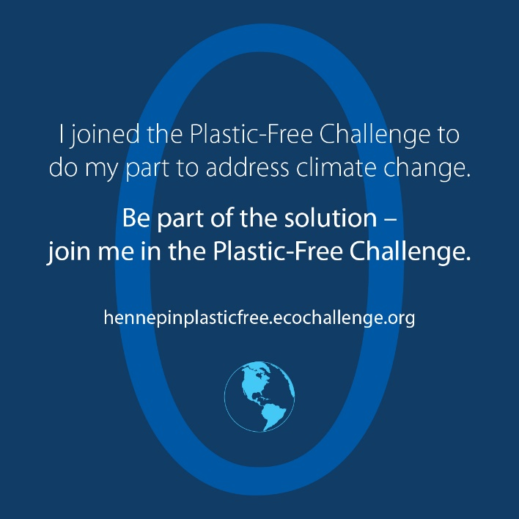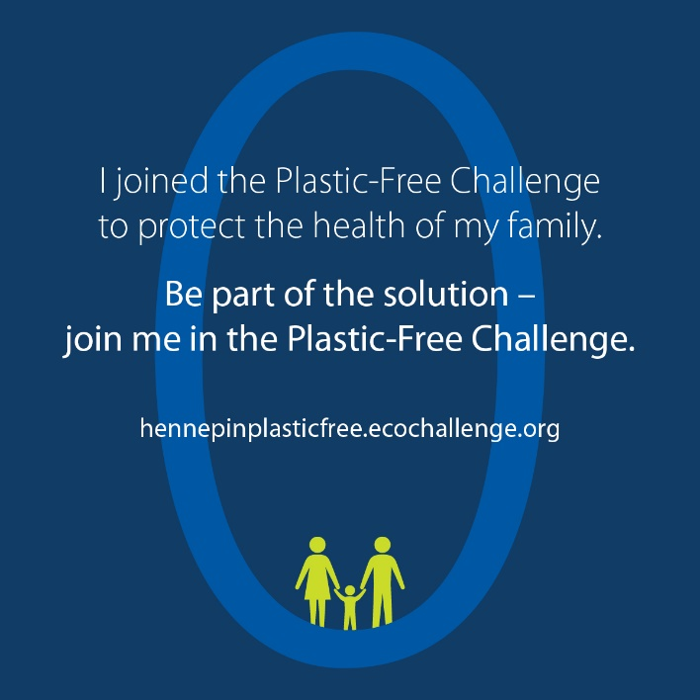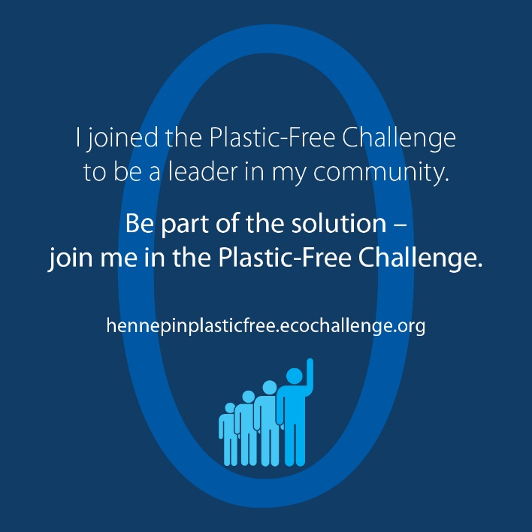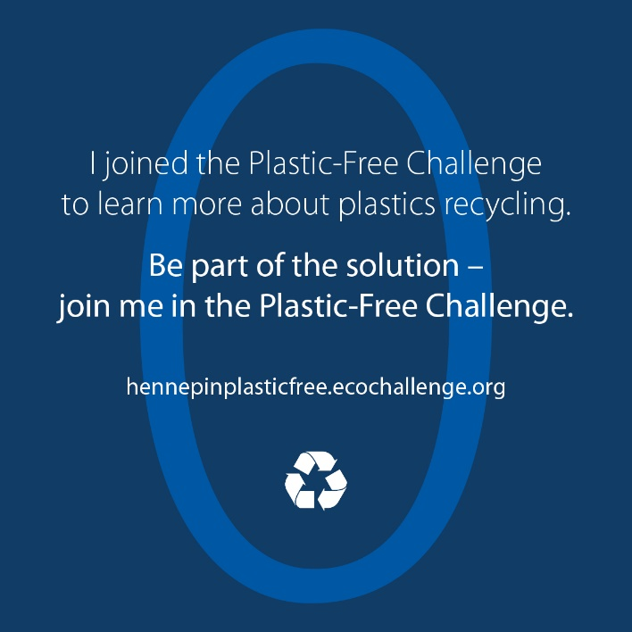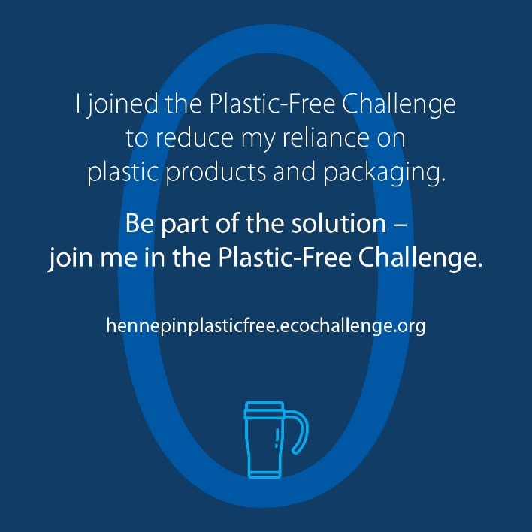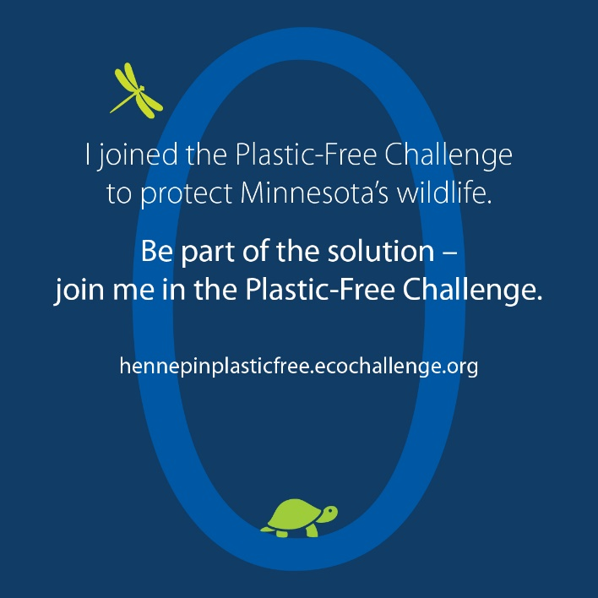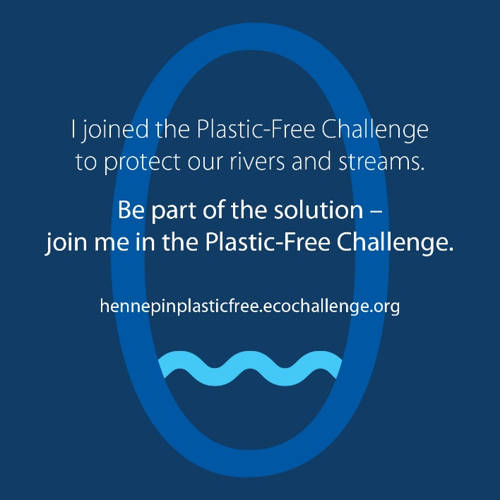

Social media posts
To use images and graphics: right click on image and select Save as Picture.

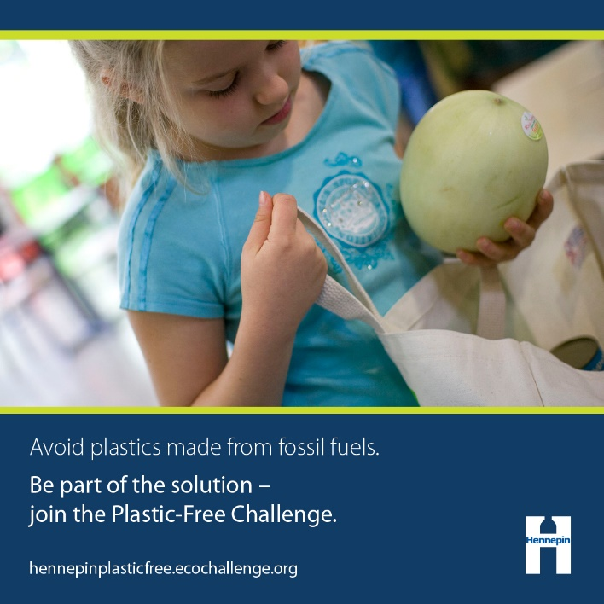
Post: Address Climate Change
Facebook and Twitter:
Most plastics are made from oil and gas – fossil fuels that contribute to climate change. This February, help create a #PlasticFree world and take action on climate change. Be part of the solution by joining the Plastic-Free Challenge at hennepinplasticfree.ecochallenge.org.
Graphic: FossilFuels
Alt text: Young girl putting melon in reusable grocery bag. Avoid plastics made from fossil fuels. Be part of the solution - join the Plastic-Free Challenge. hennepinplasticfree.ecochallenge.org

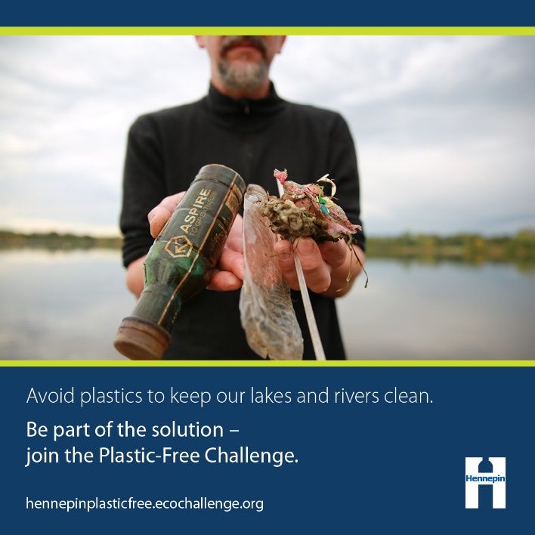
Post: Intrinsic value of water
Facebook and Twitter:
Clean water is essential to the health of our environment, wildlife, and ourselves. This February, go #PlasticFree to protect the health of our rivers and lakes. Be part of the solution by joining the Plastic-Free Challenge at hennepinplasticfree.ecochallenge.org.
Graphic: LakesRivers
Alt text: Man holding plastic litter. Avoid plastics to keep our lakes and rivers clean. Be part of the solution - join the Plastic-Free Challenge. hennepinplasticfree.ecochallenge.org

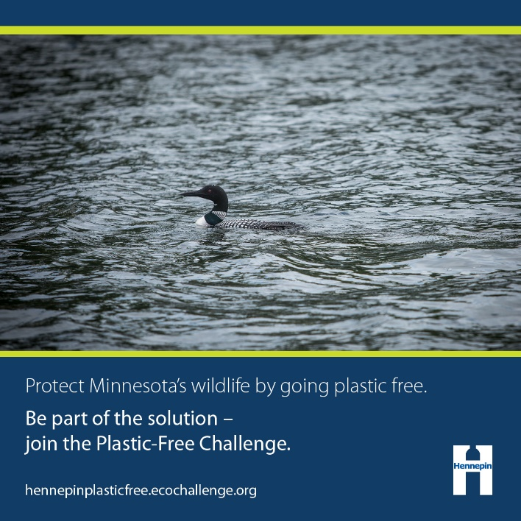
Post: Intrinsic value of wildlife
Facebook and Twitter:
Minnesota’s valuable wildlife need an environment that is clean and free of plastic pollution. Keep our iconic animals thriving by going #PlasticFree this February. Be part of the solution by joining the Plastic-Free Challenge at hennepinplasticfree.ecochallenge.org.
Graphic: Wildlife
Alt text: Loon swimming in lake. Protect Minnesota's wildlife by going plastic free. Be part of the solution - join the Plastic-Free Challenge. hennepinplasticfree.ecochallenge.org

Post: Protect the health of your family and future generations
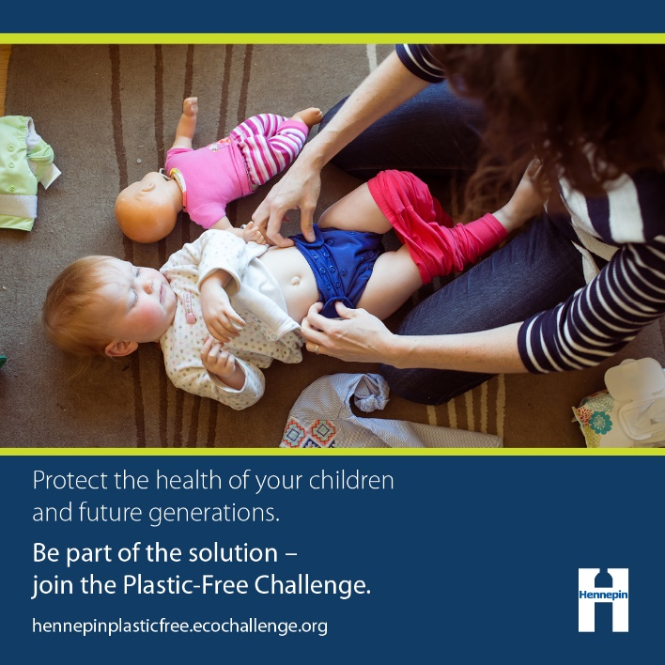
Facebook:
Plastics in our environment don’t go away. Instead, they break down into microplastics that are found almost everywhere, including in our air, water, soil, and bodies. The health impacts of these tiny bits of plastic are largely unknown. Some plastics contain harmful chemicals that interfere with the body’s hormones. Reduce your family’s reliance on plastics to protect the health of your children and the environment for future generations. Be part of the solution by joining the Plastic-Free Challenge at hennepinplasticfree.ecochallenge.org.
Twitter:
Plastics in our environment break down into tiny microplastics with unknown and potentially harmful health impacts. Reduce your family’s reliance on #Plastics to protect their health. Be part of the solution by joining the Plastic-Free Challenge at hennepinplasticfree.ecochallenge.org.
Graphic: Future Generations
Alt text: Woman changing infant's cloth diaper. Protect the health of your children and future generations. Be part of the solution - join the Plastic-Free Challenge. hennepinplasticfree.ecochallenge.org

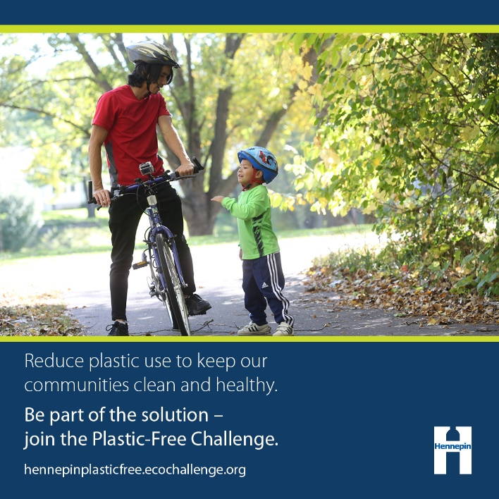
Post: Recreational value of nature
Facebook:
Nature is vital for the wellbeing of our communities. Keeping our environment clean and free from plastic pollution protects the health of our families and neighbors. Do your part this February to reduce waste, protect water and wildlife, and look after the health of ourselves and our children. Go #PlasticFree. Be part of the solution by joining the Plastic-Free Challenge at hennepinplasticfree.ecochallenge.org.
Twitter:
Nature is vital for the wellbeing of our communities. Do your part this February to keep our environment clean and free from plastic pollution. Go #PlasticFree. Be part of the solution by joining the Plastic-Free Challenge at hennepinplasticfree.ecochallenge.org.
Graphic: Recreation
Alt text: Man biking with young boy. Reduce plastic use to keep our communities clean and healthy. Be part of the solution - join the Plastic-Free Challenge. hennepinplasticfree.ecochallenge.org

Post: Be a changemaker
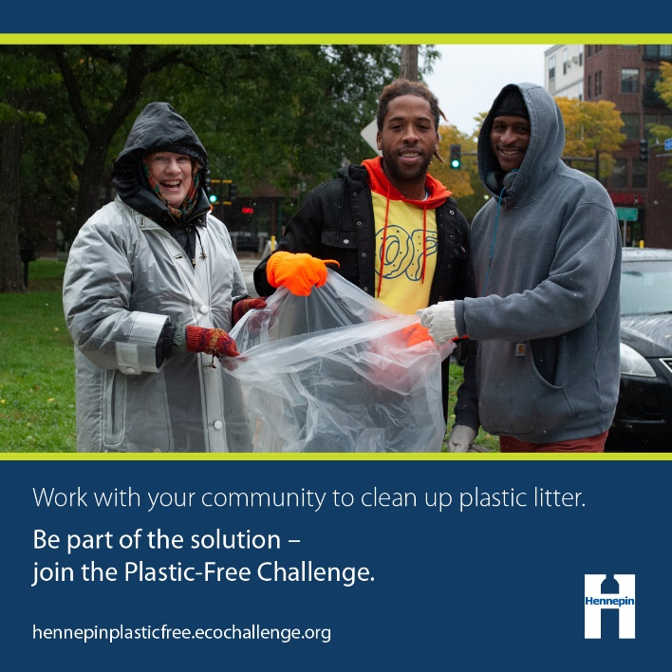
Facebook and Twitter:
Take the next step and be a zero-waste leader by influencing your family, friends, and community to reduce their plastic use and clean up plastic litter. By working together, we can create a #PlasticFree world. Be part of the solution by joining the Plastic-Free Challenge at hennepinplasticfree.ecochallenge.org.
Graphic: Community
Alt text: Group of three people posing with gloves and trash bag. Work with your community to clean up plastic litter. Be part of the solution - join the Plastic-Free Challenge. hennepinplasticfree.ecochallenge.org

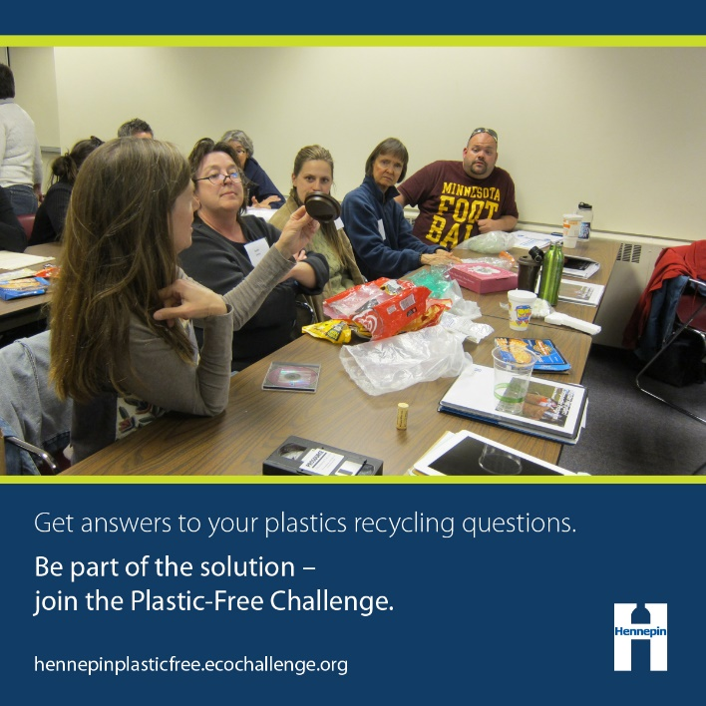
Post: Learn about plastics recycling
Facebook and Twitter:
Knowing what types plastic can be recycled and which ones should be avoided entirely can be confusing! Join your peers and learn how to do your part to create a #PlasticFree world. Be part of the solution by joining the Plastic-Free Challenge at hennepinplasticfree.ecochallenge.org
Graphic: Learning
Alt text: People surrounding table covered with various plastic items. Get answers to your plastics recycling questions. Be part of the solution - join the Plastic-Free Challenge. hennepinplasticfree.ecochallenge.org

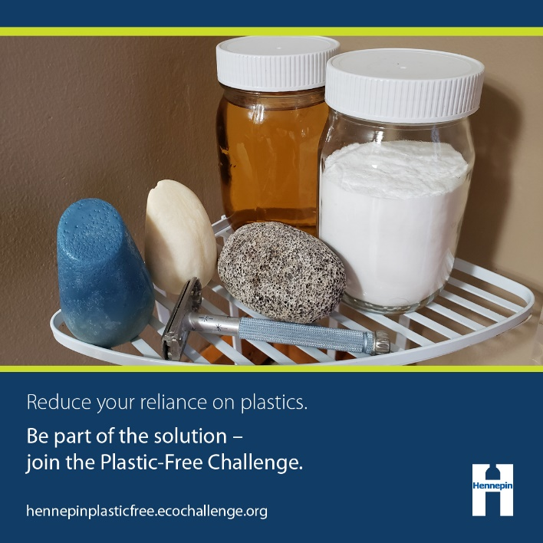
Post: DIY/Self-sustaining
Facebook:
Plastic packaging is often the default when shopping for food, personal care products, cleaning products, and more. Do your part to purchase alternative products or learn to make your own to avoid harmful plastic packaging. Our actions help create a #PlasticFree world. Be part of the solution by joining the Plastic-Free Challenge at hennepinplasticfree.ecochallenge.org.
Twitter:
Plastic packaging is hard to avoid when shopping. Do your part to purchase alternative products or learn to make your own! Our actions help create a #PlasticFree world. Be part of the solution by joining the Plastic-Free Challenge at hennepinplasticfree.ecochallenge.org.
Graphic: DIY
Alt text: Shower shelf holding personal care products without plastic packaging. Reduce your reliance on plastics. Be part of the solution - join the Plastic-Free Challenge. hennepinplasticfree.ecochallenge.org

