Promotional materials for the Plastic-Free Challenge

About the challenge
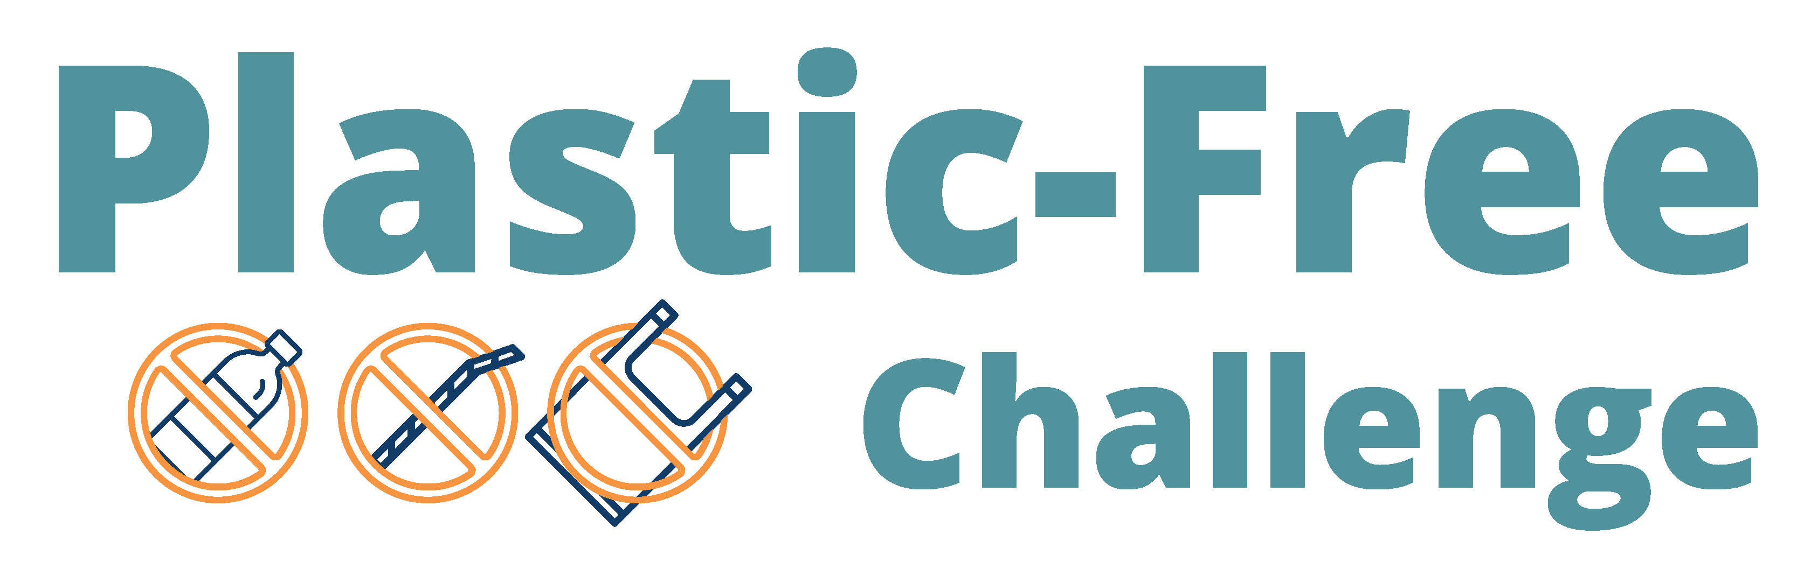
Although plastic is a versatile material with many uses, it is concerning because it presents health risks, contributes to litter and pollution, and is challenging to dispose of. Some of the most common and problematic plastic items we deal with every day come in the form of packaging and single-use plastics.
The Plastic-Free Challenge engages residents in learning about plastics and plastic waste and committing to actions that help create a plastic-free world. The challenge has 86 actions to choose from in eight categories. Participants check off the actions they already take, then select up to five one-time actions and five daily actions to track progress on during the four-week challenge.
Participants can create or join a team to take the challenge along with their family, friends, or neighbors. Organizations and businesses, including community groups, neighborhoods, schools, retailers, and more, can become a Plastic-Free Challenge partner. Partners help increase promotion, recruitment, and engagement for the challenge. The online Plastic-Free Challenge is offered in partnership with Hennepin County, Ramsey County, and Washington County and is powered by EcoChallenge.

Contact
For more information about the Plastic-Free Challenge, contact the Zero Waste Challenge coordinator at ZWC@hennepin.us

Help spread the word and encourage others to join
Some ways that you can help spread the word about the Plastic-Free Challenge and encourage others to join:
- Use the sample social media posts and graphics (starting on page 10) to share on your social media channels. These are editable so you can customize the message. Use #PlasticFree
- Use the sample newsletter articles (on pages 5 – 8) to share on an organization’s website or in newsletters. These are editable so you can customize the length or message.
- Download additional resources from tcplasticfree.ecochallenge.org/about/resources
- Become a Plastic-Free Challenge partner – details about partnership are on page 3.
- Download, print, and post or hand out flyers – linked on page 4 – to promote the event and encourage others to join your team.
- Invite people you know directly using the sample email message on page 9.
- Create a team or join an existing team and invite people you know – your friends, family, neighbors, colleagues, etc. – to join you. Your teammates will keep each other motivated and accountable. Invitations can be sent through the EcoChallenge website.
- Follow and reshare messages posted on the Hennepin, Ramsey, and Washington counties’ social media channels:
  - Hennepin County:
    - Hennepin Environment on Facebook
    - @hennepinenvironment on Instagram
    - @HennepinEnviro on Twitter
  - Ramsey County:
    - Ramsey County Minnesota on Facebook
    - @ramseycountymn on Instagram
    - @RamseyCounty on Twitter
  - Washington County:
    - Washington County MN on Facebook
    - @WashingtonCoMN on Twitter

Become a 2024 Plastic-Free Challenge partner
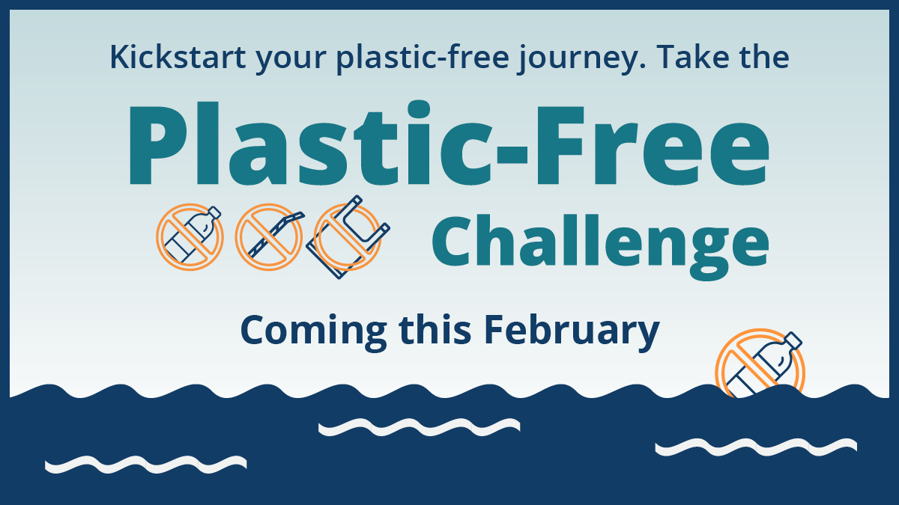
Taking steps to reduce plastic waste is one of the most effective things we can do to reduce waste and fight climate change. The Plastic-Free Challenge (tcplasticfree.ecochallenge.org), offered by Hennepin, Ramsey, and Washington counties, engages residents in learning about plastics and committing to actions that help create a plastic-free world.
But we can’t do it alone!
Organizations and businesses, including community groups, neighborhoods, schools, retailers, and more, can become partners for the upcoming Plastic-Free Challenge, which will run in February 2024. Partners help increase promotion, recruitment, and engagement for the challenge.
All partners will have their logo displayed on the challenge website, gain access to promotional materials, and get various recognition and cross-promotion during the challenge. There is no cost to becoming a partner.

Partnership opportunities include:
- Expanding our reach by promoting the challenge to your audiences.
- Strengthening engagement in the challenge by creating teams of colleagues, friends, and neighbors who motivate and hold each other accountable.
- Increasing our impact by offering educational events on plastic-free topics or discounts on plastic-free goods and services.
See the Plastic-Free Challenge partnership page to learn how to become a 2024 Plastic-Free Challenge partner. If you’re ready to join, fill out the partnership form.

Download and print posters:
Download these posters to help promote the challenge and encourage others to join your team:

Join our team
- Join our Plastic-Free Challenge team 11x17 poster (PDF)
- Join our Plastic-Free Challenge team 8.5x11 letter (PDF)

Proud to be a partner
- Proud to be a Plastic-Free Challenge partner 11x17 poster (PDF)
- Proud to be a Plastic-Free Challenge partner 8.5x11 letter (PDF)

Kickstart your plastic-free journey
- Kickstart your plastic-free journey 11x17 poster (PDF)
- Kickstart your plastic-free journey 8.5x11 letter (PDF)
- Kickstart your plastic-free journey half-page flyer (PDF)

Sample newsletter article (early promotions)
To use images and graphics: right click on the image and select Save as Picture.

Kickstart your plastic-free journey: Take the Plastic-Free Challenge
Plastics can be a hassle – they create clutter and can be confusing to recycle – plus they contribute to litter, harm water and wildlife, and have largely unknown health impacts for us. Fortunately, there’s a lot we can do to help create a plastic-free world, from learning more about plastic waste and recycling to making simple swaps to advocating for changes in your community and sharing your story with others.
Be part of the solution to reduce waste, protect water and wildlife, address climate change, and look after the health of ourselves and future generations by joining the Plastic-Free Challenge (tcplasticfree.ecochallenge.org).

About the Plastic-Free Challenge
The Plastic-Free Challenge is a month-long effort starting February 1 to reduce plastic consumption, especially single-use plastics, in ways that fit best in your lifestyle and have the most impact on reducing your footprint. Businesses, organizations, and community groups can also join the challenge as Plastic-Free Challenge partners.
The challenge runs during the month of February 2024. Registration opens on January 1. Sign up to be notified when registration opens.

Sample newsletter article (long)

Kickstart your plastic-free journey: Take the Plastic-Free Challenge
Plastics can be a hassle – they create clutter and can be confusing to recycle – plus they contribute to litter, harm water and wildlife, and have largely unknown health impacts for us. Fortunately, there’s a lot we can do to help create a plastic-free world, from learning more about plastic waste and recycling to making simple swaps to advocating for changes in your community and sharing your story with others.
Be part of the solution to reduce waste, protect water and wildlife, address climate change, and look after the health of ourselves and future generations by joining the Plastic-Free Challenge (tcplasticfree.ecochallenge.org).
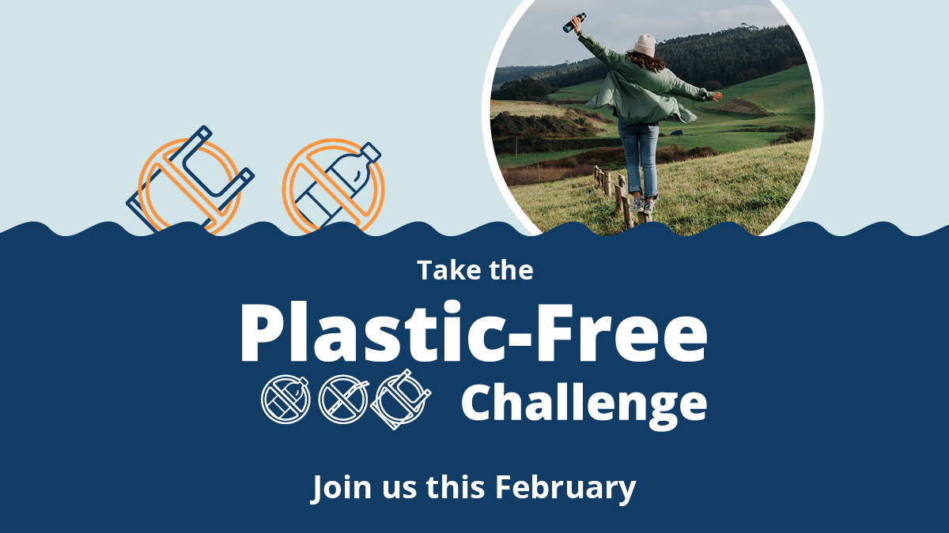

The problem with plastics
Plastics are problematic for many reasons. Worldwide, plastic production has skyrocketed since the 1970s, and a lot of the growth has come in the form of packaging and single-use plastics.
Most plastics are made from oil and gas – fossil fuels that contribute to climate change. About 4% to 8% of the world's oil production is for plastics, and most plastics are thrown away after a single use.
Since packaging and single-use plastics are used for a short period of time and then discarded, they contribute significantly to the increasing amounts of plastic waste and litter. Although recycling can be a good option for managing certain plastic items, only a small percentage of plastic products are recycled, and many types of plastic are hard to recycle.
Unlike items made from natural materials like plants that can be composted and returned to the soil, plastics don’t go away. Instead, they break down into smaller pieces of plastic. These microplastic pieces are now found almost everywhere, including in our air, water, soil, and bodies. Plastics in the environment pollute our water, harm wildlife, and have largely unknown health impacts for us.
Joining the Plastic-Free Challenge helps you be part of the solution by increasing your understanding of plastics and plastic waste, uncovering opportunities to cut back on the amount of plastic you bring into your home, and connecting you with opportunities to advocate for change in your community.

About the Plastic-Free Challenge
The Plastic-Free Challenge is a month-long effort starting February 1 to reduce plastic consumption, especially single-use plastics, in ways that fit best in your lifestyle and have the most impact on reducing your footprint.
The challenge has 86 actions to choose from in eight categories. Sign up opens on January 1, and the challenge runs during the month of February 2024. Once you sign up and create your profile, you can browse the categories and actions, check off the actions you already take, and select up to five one-time actions and five daily actions to make progress on during the four-week challenge.
You can also create a team to take the challenge along with your family, friends, neighbors, and colleagues. Or encourage an organization, business, or community group you are a part of to become a Plastic-Free Challenge partner.
Once the challenge starts, you will report what actions you take, see the impact of your actions add up, connect with others, and support your team members to keep them motivated and accountable.
Hennepin, Ramsey, and Washington counties are working jointly to reduce plastic waste as part of achieving our zero waste and climate action goals. Engaging residents in taking action is a critical part of our success. The online Plastic-Free Challenge is powered by EcoChallenge.
Learn more, sign up, and get ready to kickstart your plastic-free journey at tcplasticfree.ecochallenge.org.

Sample newsletter article (short)

Kickstart your plastic-free journey: Take the Plastic-Free Challenge
Plastics can be a hassle – they create clutter and can be confusing to recycle – plus they contribute to litter, harm water and wildlife, and have largely unknown health impacts for us. Fortunately, there’s a lot we can do to help create a plastic-free world, from learning more about plastic waste and recycling to making simple swaps to advocating for changes in your community and sharing your story with others.
Be part of the solution to reduce waste, protect water and wildlife, address climate change, and look after the health of ourselves and future generations by joining the Plastic-Free Challenge (tcplasticfree.ecochallenge.org).

About the Plastic-Free Challenge
The Plastic-Free Challenge is a month-long effort starting February 1 to reduce plastic consumption, especially single-use plastics, in ways that fit best in your lifestyle and have the most impact on reducing your footprint.
The challenge has 86 actions to choose from in eight categories. Sign up opens on January 1, and the challenge runs during the month of February 2024. Once you sign up and create your profile, you can browse the categories and actions, check off the actions you already take, and select up to five one-time actions and five daily actions to make progress on during the four-week challenge.
You can also create a team to take the challenge along with your family, friends, neighbors, and colleagues. Or encourage an organization, business, or community group you are a part of to become a Plastic-Free Challenge partner.
Learn more, sign up, and get ready to kickstart your plastic-free journey at tcplasticfree.ecochallenge.org.

Sample email message
Dear [name],
I am constantly amazed – and a bit overwhelmed – by the number of plastic items that I end up using and bringing into my home. Despite my efforts to avoid them, my trash and recycling bin still include a lot of single-use and disposable plastics. I am concerned about plastics because they present health risks, create litter and pollution, contribute to climate change, and are challenging to dispose of.
That’s why this February, I’m joining the Plastic-Free Challenge and committing to actions that help me be part of the solution toward creating a plastic-free world.
Through the Plastic-Free Challenge, I’m looking forward to learning about plastics and plastic waste and uncovering opportunities to cut back on the amount of plastic I bring into my home in ways that fit best in my lifestyle.
[Insert a personal message – why is this important to you, why do you think this person would be interested in joining, invite them to join your team, etc.]
The challenge has 86 actions to choose from in eight categories. Once you sign up, you can check off the actions you already take, then select up to five one-time actions and five daily actions to make progress on during the four-week challenge. You can also see the impact of your actions, see how you are doing compared to others, and connect with others who are taking action.
Sign up opens on January 1, and the challenge runs during the month of February 2024. Learn more, sign up, and get ready to kickstart your plastic-free journey at tcplasticfree.ecochallenge.org.

Sincerely,
[your name]

Social media posts (early promotions)
To use images and graphics: right click on the image and select Save as Picture.
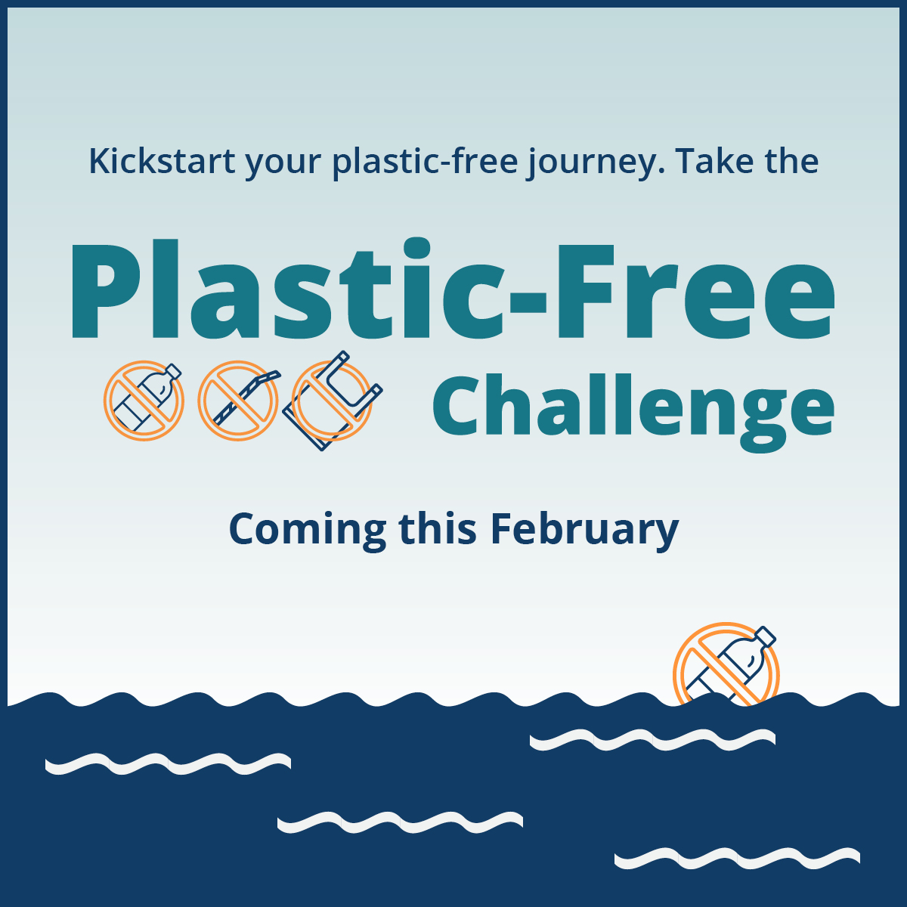
Suggested hashtags: #PlasticFreeChallenge #PlasticFree #ZeroWaste

Get notified when sign up is open

Facebook:
Kickstart your plastic-free journey with the Plastic-Free Challenge this February! You can be part of the solution to reduce waste, protect water and wildlife, address climate change, and look after the health of ourselves and future generations. Get notified when sign up opens: public.govdelivery.com/accounts/MNHENNE/signup/38814

Twitter/X:
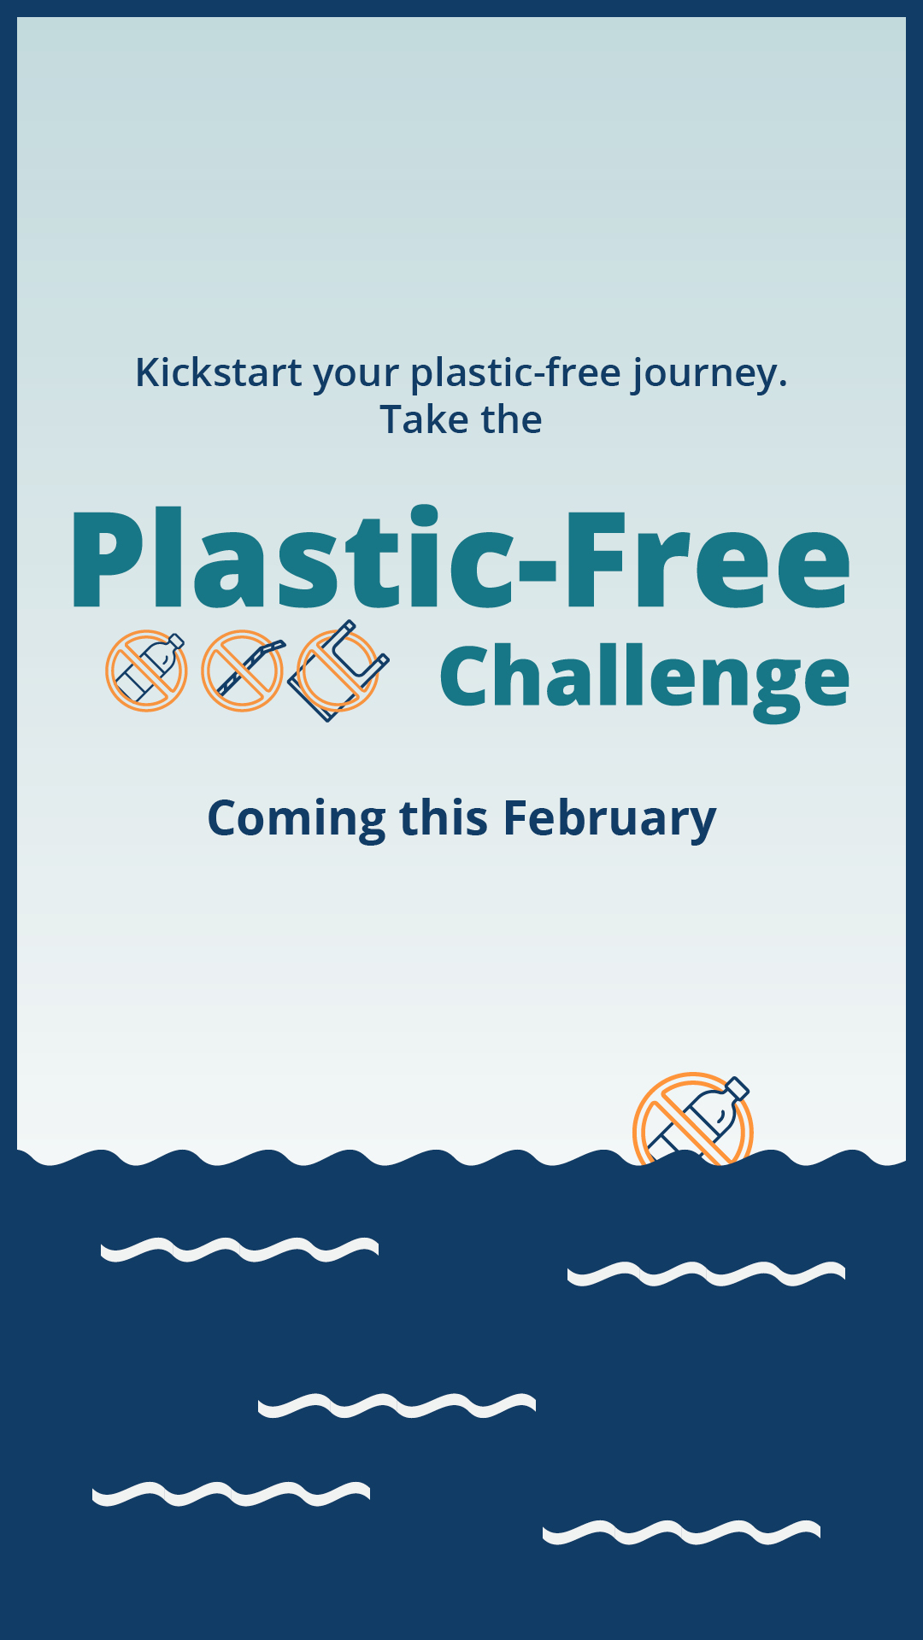
Kickstart your plastic-free journey with the Plastic-Free Challenge this February! You can be part of the solution to reduce waste, protect water and wildlife, and address climate change. Get notified when sign up opens: public.govdelivery.com/accounts/MNHENNE/signup/38814 #PlasticFreeChallenge

Instagram:
Kickstart your plastic-free journey with the Plastic-Free Challenge this February! You can be part of the solution to reduce waste, protect water and wildlife, address climate change, and look after the health of ourselves and future generations. Get notified when sign up opens at the link in our bio. #PlasticFreeChallenge #PlasticFree #ZeroWaste

Nextdoor:
Kickstart your plastic-free journey with the Plastic-Free Challenge this February! You can be part of the solution to reduce waste, protect water and wildlife, address climate change, and look after the health of ourselves and future generations. Get notified when sign up opens: public.govdelivery.com/accounts/MNHENNE/signup/38814

Social media posts
Suggested hashtags: #PlasticFreeChallenge #PlasticFree #ZeroWaste
Social media messages for Facebook, Twitter/X, and Instagram posts are crafted to resonate with specific priority audience groups. Consider where your audience is in their zero-waste journey when choosing which messages to promote. Some messages below are appropriate for all audiences. Pair these messages with a graphic to promote the challenge (Find the full library of graphics starting on page 16).
- Zero waste learners: This audience is somewhat aware of problems with waste and may be doing a few things, but they are likely overwhelmed or unsure where to start. Some are narrowly focused on recycling.
- Zero waste leaders: This audience is already taking action but know they could do more. They may be looking to influence others and need guidance and support.
- Zero waste pros: This audience is already doing a lot and are looking to truly get to zero waste. They are eager to advocate for large-scale changes.

Message group 1 – Recycling, plastic types

Post: Learn about plastics recycling – learners
Facebook: Knowing what plastics can be recycled and which ones should be avoided entirely can be confusing! Join your peers and learn how to do your part to create a plastic-free world. Kickstart your plastic-free journey at tcplasticfree.ecochallenge.org
Twitter/X: Knowing what plastics can be recycled and which ones should be avoided entirely can be confusing! Join your peers and learn how to do your part to create a #PlasticFree world. Kickstart your plastic-free journey at tcplasticfree.ecochallenge.org #PlasticFreeChallenge #ZeroWaste
Instagram: Knowing what plastics can be recycled and which ones should be avoided entirely can be confusing! Join your peers and learn how to do your part to create a #PlasticFree world. Kickstart your plastic-free journey at the link in our bio. #PlasticFreeChallenge #ZeroWaste

Post: Plastic types – learners
Facebook: Did you know there are seven types of plastics? This is what the number 1 – 7 printed on a plastic item tells you. Although the triangle looks like a recycling symbol, it only tells you what type of plastic an item is, not if or how you can recycle it. Plastic bottles, jugs, and containers with a number 1, 2, and 5 are generally accepted in your recycling at home because there are good markets for recycling these items. Learn more about different plastic types and kickstart your plastic-free journey at tcplasticfree.ecochallenge.org
Twitter/X: Did you know there are seven plastic types? The number 1-7 printed on an item tells you what type of plastic it is, but not if or how to recycle it. Plastic bottles, jugs, and containers numbered 1, 2, and 5 can generally be recycled at home. tcplasticfree.ecochallenge.org #ZeroWaste
Instagram: Did you know there are seven types of plastics? This is what the number 1 – 7 printed on a plastic item tells you. Although the triangle looks like a recycling symbol, it only tells you what type of plastic an item is, not if or how you can recycle it. Plastic bottles, jugs, and containers with a number 1, 2, and 5 are generally accepted in your recycling at home because there are good markets for recycling these items. Learn more about different plastic types and kickstart your plastic-free journey at the link in our bio. #PlasticFreeChallenge #PlasticFree #ZeroWaste

Post: Recycling is not a myth – learners
Facebook: Recycling is effective when we recycle the right things. Plastic bottles, jugs, cups, and containers can be recycled into new products, including plastic bottles, carpeting, decking, and lawn furniture. To ensure plastic recycling is as effective as possible, learn what items can be recycled and what to keep out of your recycling bin. Kickstart your plastic-free journey at tcplasticfree.ecochallenge.org
Twitter/X: Recycling is effective when we recycle the right things. Plastic bottles, jugs, cups, and containers can be recycled into new products like bottles, carpeting, and decking. Kickstart your plastic-free journey at tcplasticfree.ecochallenge.org #PlasticFreeChallenge #PlasticFree #ZeroWaste
Instagram: Recycling is effective when we recycle the right things. Plastic bottles, jugs, cups, and containers can be recycled into new products, including plastic bottles, carpeting, decking, and lawn furniture. To ensure plastic recycling is as effective as possible, learn what items can be recycled and what to keep out of your recycling bin. Kickstart your plastic-free journey at the link in our bio. #PlasticFreeChallenge #PlasticFree #ZeroWaste

Message group 2 – Natural resources, wildlife, water

Post: Address climate change – all
Facebook: Most plastics are made from oil and gas – fossil fuels that contribute to climate change. This February, commit to using fewer disposable plastic items to take action on climate change. Kickstart your plastic-free journey at tcplasticfree.ecochallenge.org
Twitter/X: Most plastics are made from oil and gas – fossil fuels that contribute to climate change. This February, commit to using fewer disposable plastic items to take action on climate change. Kickstart your plastic-free journey at tcplasticfree.ecochallenge.org #PlasticFree #ZeroWaste
Instagram: Most plastics are made from oil and gas – fossil fuels that contribute to climate change. This February, commit to using fewer disposable plastic items to take action on climate change. Kickstart your plastic-free journey at the link in our bio. #PlasticFreeChallenge #PlasticFree #ZeroWaste

Post: Intrinsic value of water – all
Facebook: Clean water is essential to the health of our environment, wildlife, and ourselves. Unfortunately, plastics in our environment don't go away. Instead, they break down into smaller pieces of plastic that pollute our water and harm wildlife. This February, go plastic-free to protect our rivers and lakes. Kickstart your plastic-free journey at tcplasticfree.ecochallenge.org
Twitter/X: Clean water is essential to the health of our environment, wildlife, and ourselves. This February, go #PlasticFree to protect our rivers and lakes. Kickstart your plastic-free journey at tcplasticfree.ecochallenge.org #PlasticFreeChallenge #ZeroWaste
Instagram: Clean water is essential to the health of our environment, wildlife, and ourselves. Unfortunately, plastics in our environment don't go away. Instead, they break down into smaller pieces of plastic that pollute our water and harm wildlife. This February, go #PlasticFree to protect our rivers and lakes. Kickstart your plastic-free journey at the link in our bio. #PlasticFreeChallenge #ZeroWaste

Post: Intrinsic value of wildlife – all
Facebook: Minnesota’s valuable wildlife need an environment that is clean and free of plastic pollution. Keep our iconic animals thriving by going plastic-free this February. Kickstart your plastic-free journey at tcplasticfree.ecochallenge.org
Twitter/X: Minnesota’s valuable wildlife need an environment that is clean and free of plastic pollution. Keep our iconic animals thriving by going #PlasticFree this February. Kickstart your plastic-free journey at tcplasticfree.ecochallenge.org #PlasticFreeChallenge #ZeroWaste
Instagram: Minnesota’s valuable wildlife need an environment that is clean and free of plastic pollution. Keep our iconic animals thriving by going #PlasticFree this February. Kickstart your plastic-free journey at the link in our bio. #PlasticFreeChallenge #ZeroWaste

Message group 3 – Health, family, children

Post: Protect the health of your family and future generations – all
Facebook: Plastics in our environment don’t go away. Instead, they break down into tiny microplastics that have unknown and potentially harmful health impacts. Reduce your family’s reliance on plastics to protect the health of your children and the environment for future generations. Kickstart your plastic-free journey at tcplasticfree.ecochallenge.org
Twitter/X: Plastics in our environment break down into tiny microplastics with unknown and potentially harmful health impacts. Reduce your family’s reliance on #Plastics to protect their health. Kickstart your plastic-free journey at tcplasticfree.ecochallenge.org #PlasticFreeChallenge #ZeroWaste
Instagram: Plastics in our environment don’t go away. Instead, they break down into tiny microplastics that have unknown and potentially harmful health impacts. Reduce your family’s reliance on plastics to protect the health of your children and the environment for future generations. Kickstart your plastic-free journey at the link in our bio. #PlasticFreeChallenge #PlasticFree #ZeroWaste

Post: Microplastics – all
Facebook: Microplastics shed from synthetic clothing and produced when large plastic items are broken down by the sun are harmful to fish and other aquatic animals. When we eat fish that have ingested microplastics, those harmful effects may be passed on to us. Kickstart your plastic-free journey at tcplasticfree.ecochallenge.org
Twitter/X: Microplastics are harmful to aquatic animals such as fish. When we eat fish that have ingested microplastics, those harmful effects may be passed on to us. Kickstart your plastic-free journey at tcplasticfree.ecochallenge.org #PlasticFreeChallenge #PlasticFree #ZeroWaste
Instagram: Microplastics shed from synthetic clothing and produced when large plastic items are broken down by the sun are harmful to fish and other aquatic animals. When we eat fish that have ingested microplastics, those harmful effects may be passed on to us. Kickstart your plastic-free journey at the link in our bio. #PlasticFreeChallenge #PlasticFree #ZeroWaste

Message group 4 – Advocacy, action, influence, community

Post: Advocate for change – pros and leaders
Facebook: Ask your favorite restaurant to get rid of single-use plastic and support businesses that are taking action to help create a plastic-free world. Learn how by joining the Plastic-Free Challenge and committing to actions in the community category at tcplasticfree.ecochallenge.org
Twitter/X: Ask your favorite restaurant to get rid of single-use plastic and support businesses that are taking action to create a #PlasticFree world. Learn how by joining the Plastic-Free Challenge and committing to actions in the community category at tcplasticfree.ecochallenge.org #PlasticFreeChallenge #ZeroWaste
Instagram: Ask your favorite restaurant to get rid of single-use plastic and support businesses that are taking action to help create a #PlasticFree world. Learn how by joining the Plastic-Free Challenge and committing to actions in the community category at the link in our bio. #PlasticFreeChallenge #ZeroWaste

Post: Be an influencer – pros and leaders
Facebook: Be a zero-waste leader by encouraging your family, friends, and community to join the Plastic-Free Challenge this February and reduce their plastic use. By working together, we can create a plastic-free world. Kickstart your plastic-free journey at tcplasticfree.ecochallenge.org
Twitter/X: Be a zero-waste leader by encouraging your family, friends, and community to join the Plastic-Free Challenge this February and reduce their plastic use. Together, we can create a #PlasticFree world. Kickstart your plastic-free journey at tcplasticfree.ecochallenge.org #PlasticFreeChallenge #ZeroWaste
Instagram: Be a zero-waste leader by encouraging your family, friends, and community to join the Plastic-Free Challenge this February and reduce their plastic use. By working together, we can create a #PlasticFree world. Kickstart your plastic-free journey at the link in our bio. #PlasticFreeChallenge #ZeroWaste

Post: DIY/Self-sustaining – pros and leaders
Facebook: Plastic packaging is often the default when shopping for food, personal care products, cleaning products, and more. Do your part to purchase alternative products or learn to make your own to avoid harmful plastic packaging. Learn how and kickstart your plastic-free journey at tcplasticfree.ecochallenge.org
Twitter/X: Plastic packaging is hard to avoid when shopping. Do your part to purchase alternative products or learn to make your own to avoid harmful plastic packaging. Learn how and kickstart your plastic-free journey at tcplasticfree.ecochallenge.org #PlasticFreeChallenge #PlasticFree #ZeroWaste
Instagram: Plastic packaging is often the default when shopping for food, personal care products, cleaning products, and more. Do your part to purchase alternative products or learn to make your own to avoid harmful plastic packaging. Learn how and kickstart your plastic-free journey at the link in our bio. #PlasticFreeChallenge #PlasticFree #ZeroWaste

Library of social media graphics
Download full resolution graphics here: tcplasticfree.ecochallenge.org/about/resources
Pair the social media messages above with a graphic to promote the challenge.
To use images and graphics: right click on the image and select Save as Picture.

Square graphics
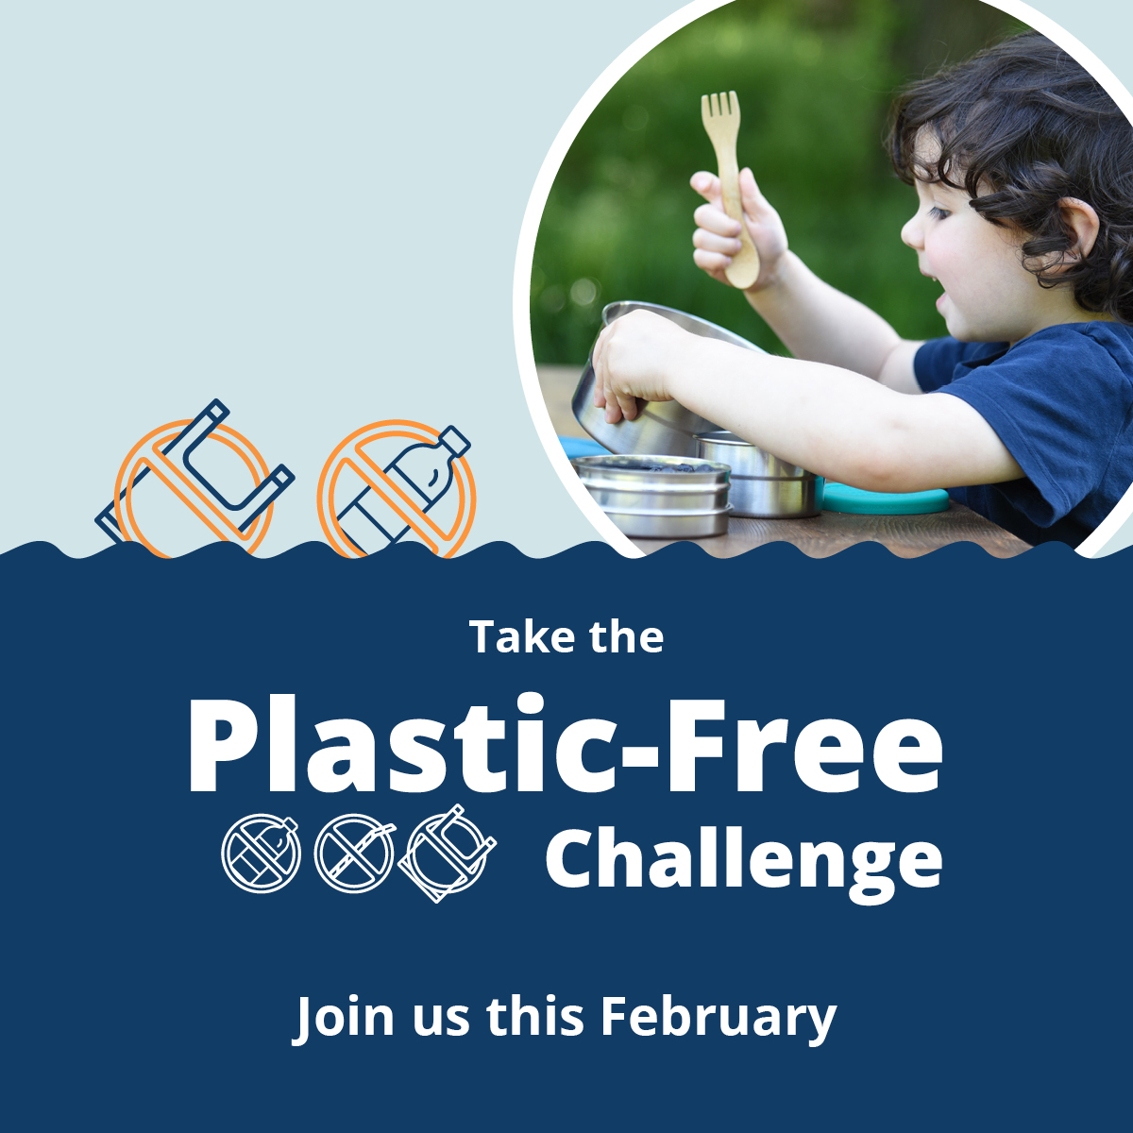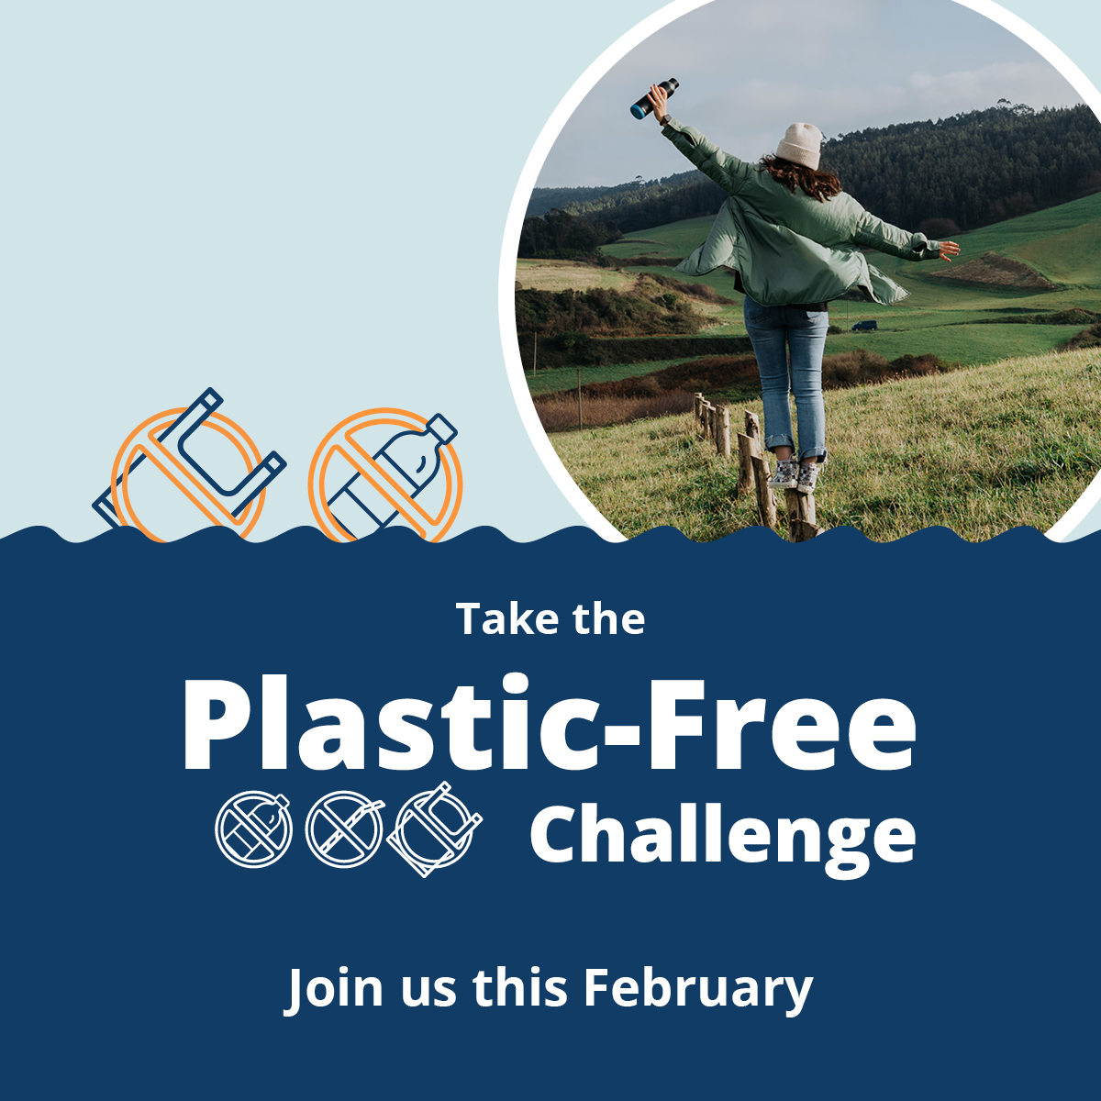
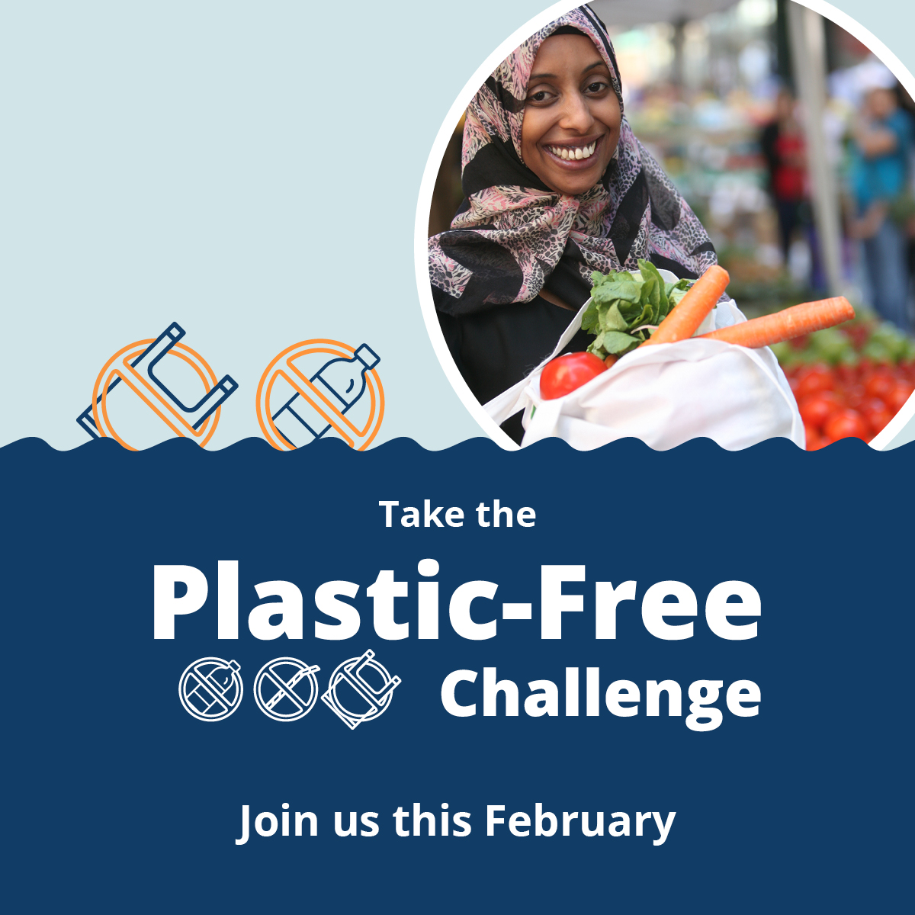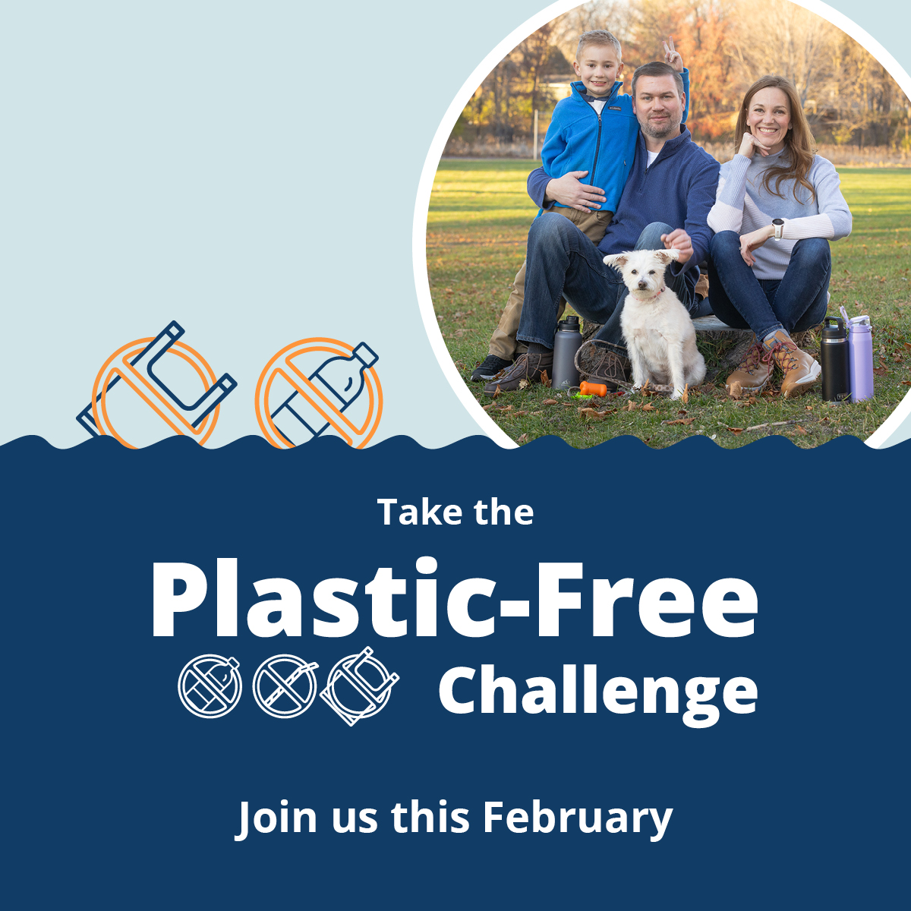
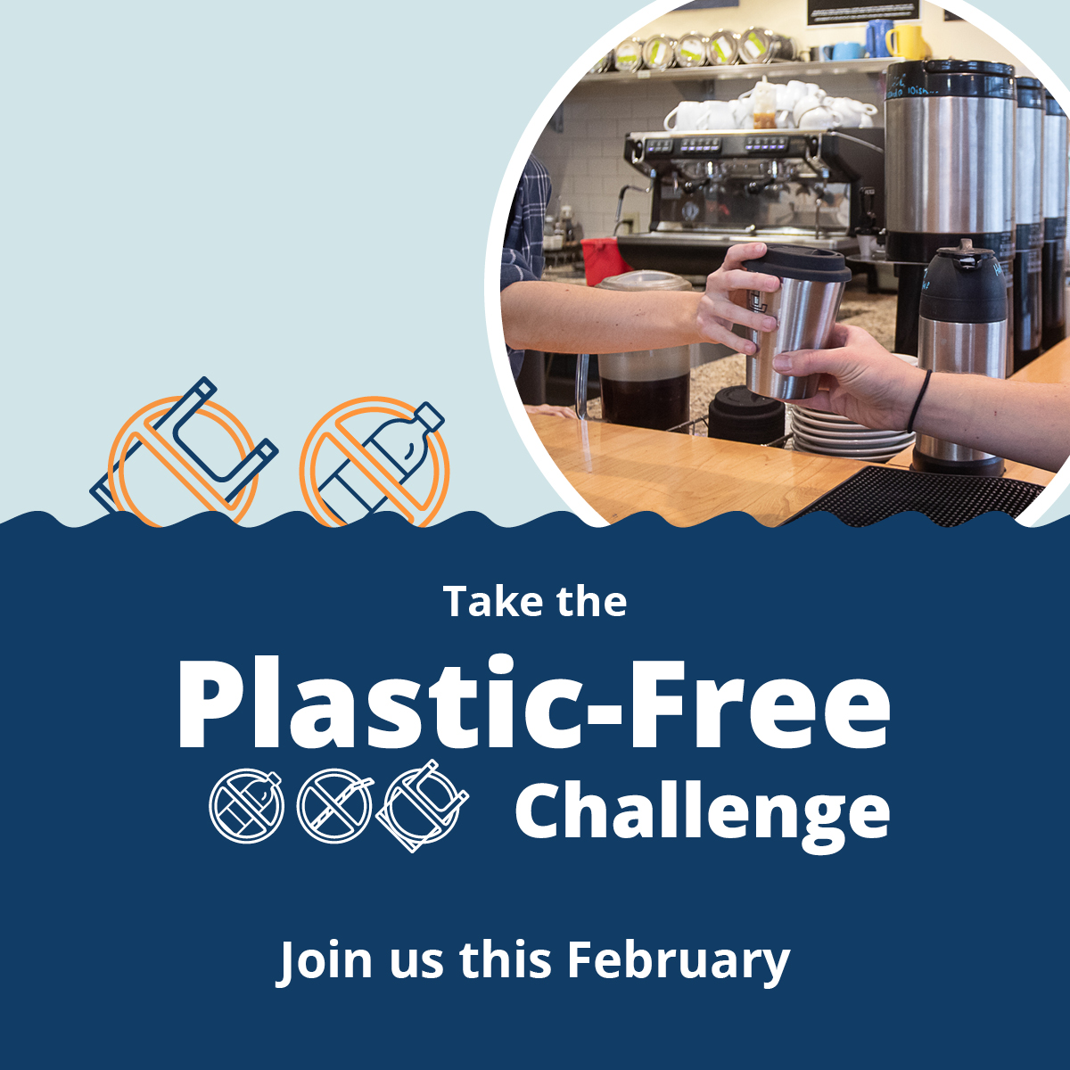

675x1200 rectangle graphics
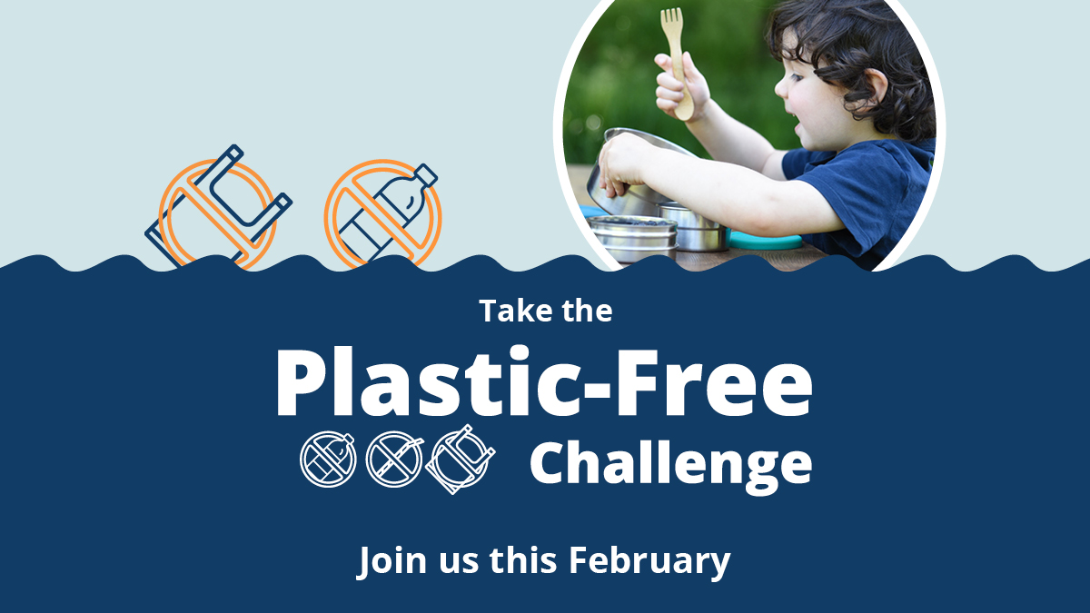
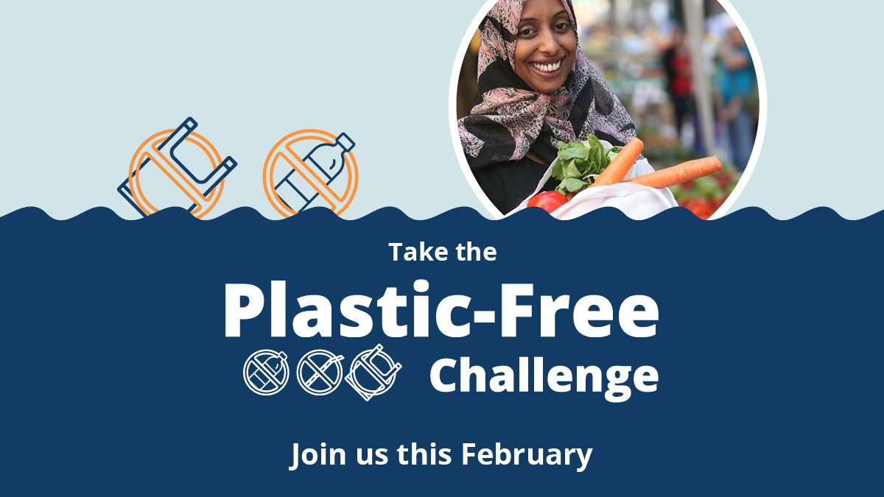
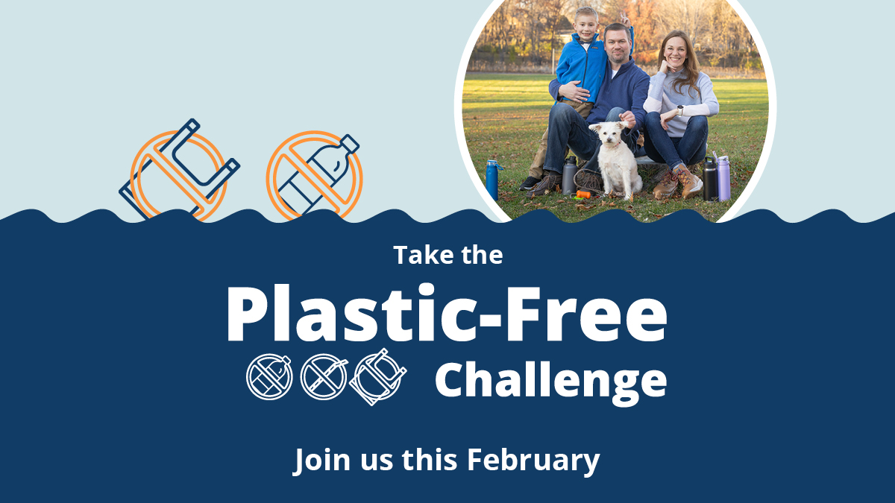
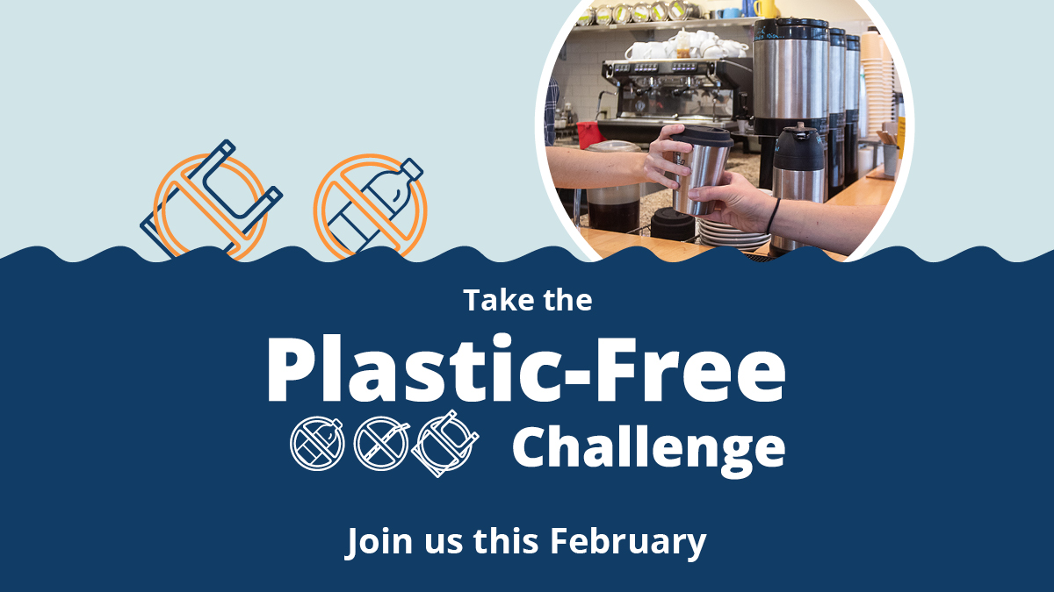

1920x1080 Instagram story graphics
Consider adding a link to the Plastic-Free Challenge website or a relevant action category:
- tcplasticfree.ecochallenge.org
- tcplasticfree.ecochallenge.org/challenges/plastics-101
- tcplasticfree.ecochallenge.org/challenges/at-home
- tcplasticfree.ecochallenge.org/challenges/food
- tcplasticfree.ecochallenge.org/challenges/on-the-go
- tcplasticfree.ecochallenge.org/challenges/personal-care
- tcplasticfree.ecochallenge.org/challenges/community
- tcplasticfree.ecochallenge.org/challenges/kids
- tcplasticfree.ecochallenge.org/challenges/pets
